**Name: Wong Keng**

**Capstone 2 Project 1: CoreBanking**

**Filename:**

* *MainClass.java*
* *CoreBanking.java*
* *BankCustomer.java*
* *ChildAccount.java*
* *FixedDeposit.java*

1. **Objective:**

To develop a simple banking application using the Object Oriented Programming   
concept. In the process, learn about the four core pillars of OOP; namely, Abstraction, Inheritance, Polymorphism and Encapsulation.

1. **What I have done:**
2. Written 5 class files (as listed above). The CoreBanking.java file contains the majority of the classes for this application.
3. Separate the ‘public static void main’ method into a standalone java file; MainClass.java.
4. The application has the following features:
   * Create Customer
   * Create Account (Savings, Child, Fixed Deposit (FD)
   * Deposit Funds
   * Withdraw Funds
   * Balance Enquiry
   * Print Customer’s Account Details
   * Close Account
5. **Test Output**

Screenshots from my Mac:

1. File structure set up

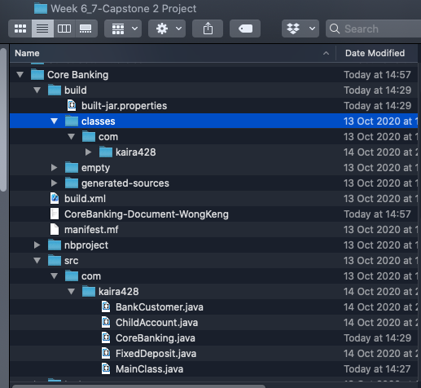

5 main java files for the Banking Application

1. Compile and Run

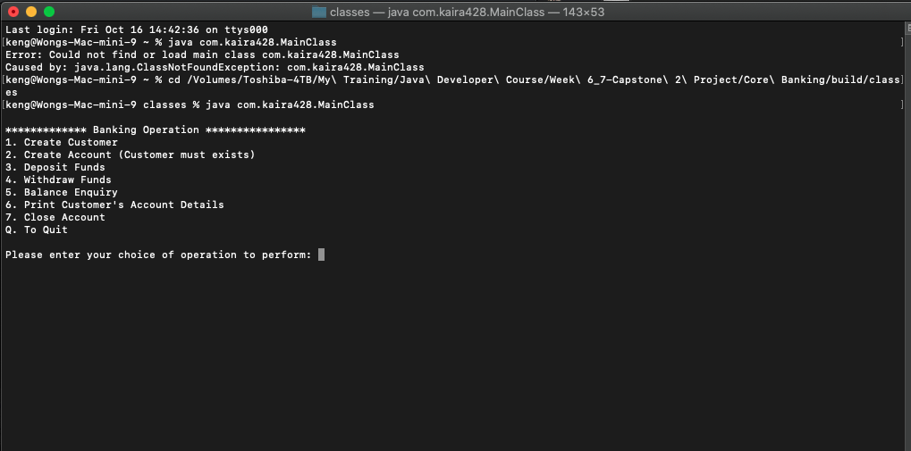

Application Main Menu

1. Create New Customer

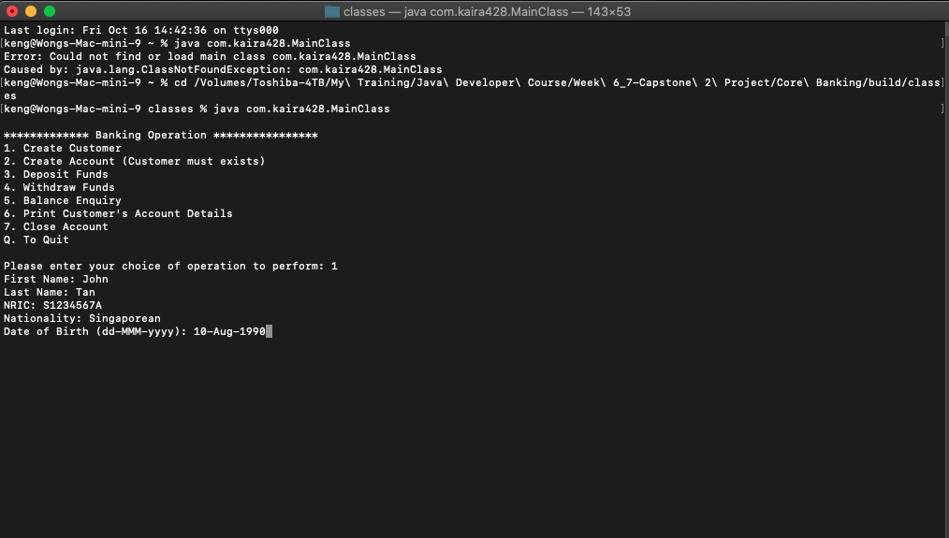

Creating new customer

1. Create customer Savings Account with initial deposit of $2000

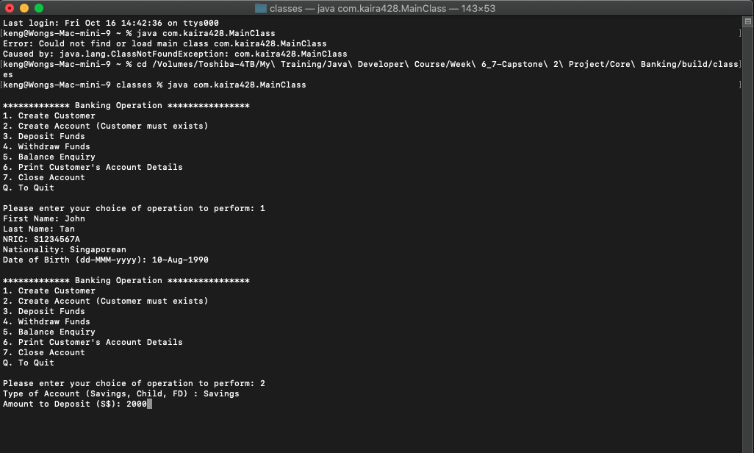

Create Savings Account

1. Savings Account created

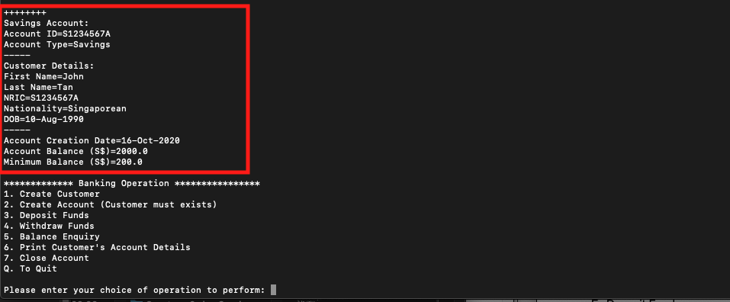

Savings Account Created

1. Deposit Funds

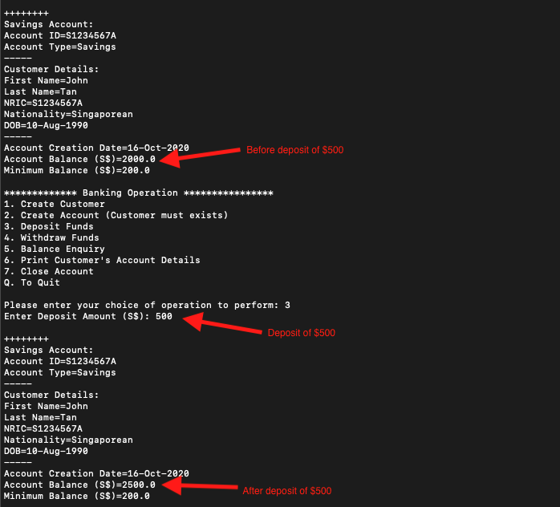

$500 deposited

1. Withdraw Funds



Withdrawal of $1000

1. Withdrawing $1400 and resulting in Savings Account minimum sum of $200 being breached

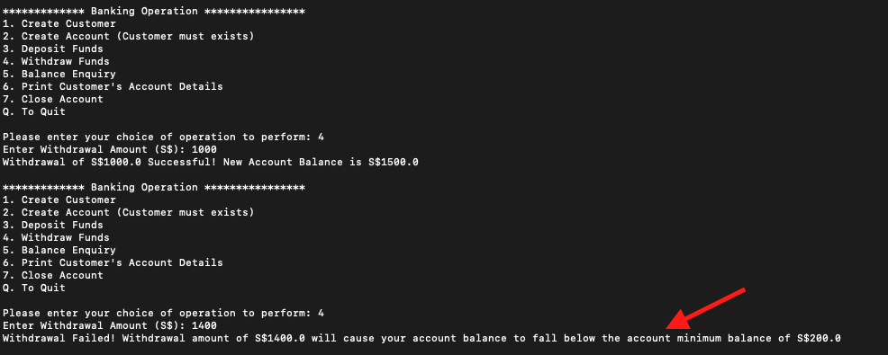

Withdrawal unsuccessful

1. Print Customer’s Account Details

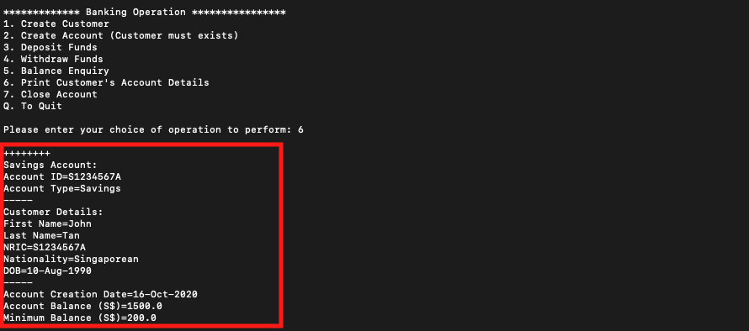

Customer’s Account Details

1. Account Closure

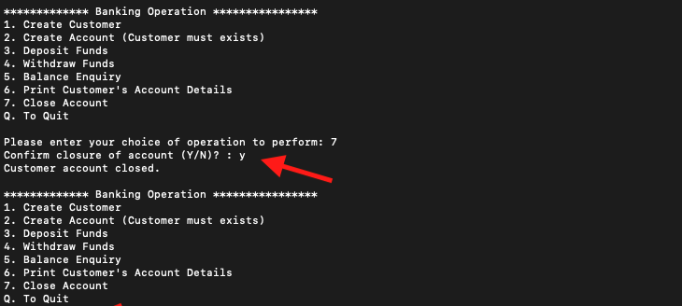

Account closed

1. Child Account



Child Account. No Minimum Balance but $30 Maximum Withdrawal Limit set by guardian, Jimmy Lim

1. Child Account - Withdrawal greater than Withdrawal Limit



Child Account - withdrawal amount greater than withdrawal limit of $30

1. Fixed Deposit (FD)



Fixed Deposit, Renewal Date automatically computed based on customer’s decision of 2 years

1. Fixed Deposit (FD) - Premature withdrawal

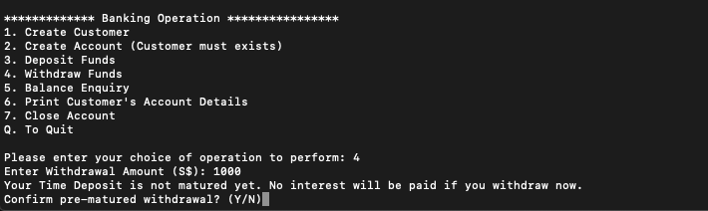

Pre-matured withdrawal of FD

1. **What did I learn:**

From this CoreBanking project, I learned the following:

* The application of the concepts of OOP.
* The use of constructors, getters, setters and the various access rights.
* The application of the DateTime class to auto-compute the account creation date and the FD renewal date.
* The application of enum class to populate the Minimum Account Balance for the respective account types.
* The concept of Package in linking up the 5 java files for compilation.